98.3. WAE from the DX (non-Europe) side
The process is even easier from the non-European (DX) side. If you want to send QTCs, you simply press Ctrl+Z. If you've forgotten to log the QSO first, Ctrl+Z will do it for you. A pop-up window opens, asking you how many QTCs you want to send to the EU station:
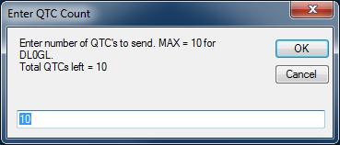
The pop-up defaults to the maximum number you can send that station, but if you want to send fewer, you can just type in the new number over the old one. When you exit from the pop-up by hitting Enter or pressing OK, the QTC header is sent to the other station, and a QTC window opens up, populated with all the information you need to send:
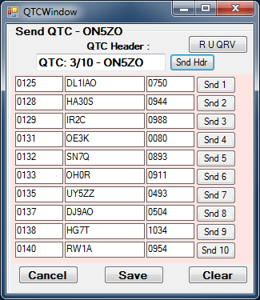

Once the other station indicates he's ready, usually with 'QRV' in CW, you can press Enter to send each QTC in turn, waiting for the other station to acknowledge after each QTC. The following screen shot shows the window after the 5th QTC has been sent - note that the highlight is on the "Snd 6" button, because that is the one that will be sent if you press Enter at this point:
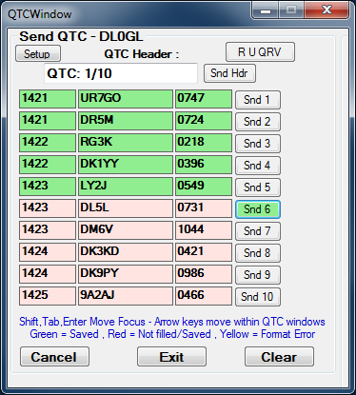
If he asks for a repeat, you can press the = key, Alt+Enter, or + key, or you can click on the "Snd" button for the previous QTC, i.e. the one that was not yet received and acknowledged. If he asks for a repeat of only part of the QTC, you can right-click on one of the three parts to re-send it, or you can press the 1, 2 or 3 keys to re-send just the time, call sign or serial number respectively. Once all of the QTCs have been sent and the European station acknowledges the QTC batch, you click on the Exit button to end the batch and log the sent QTCs. The Clear and Cancel buttons work the same way as for a station in EU.

